**DAILY ONLINE ACTIVITIES SUMMARY**

|  |  |  |  |  |  |  |  |  |
| --- | --- | --- | --- | --- | --- | --- | --- | --- |
| **Date:** | **30/07/2020** | | | | | **Name:** | **Spoorthy Balaji** | |
| **Sem & Sec** | **6th & B** | | | | | **USN:** | **4al17cs098** | |
| **Online Test Summary** | | | | | | | | |
| **Subject** | | **-** | | | | | | |
| **Max. Marks** | | **-** | | **Score** | | | **-** | |
| **Certification Course Summary** | | | | | | | | |
| **Course** | **Introduction to CSS3** | | | | | | | |
| **Certificate Provider** | | | **Coursera** | | **Duration** | | | **4 Weeks** |
| **Coding Challenges** | | | | | | | | |
| **Problem Statement: Python Program for Program to calculate area of a Tetrahedron** | | | | | | | | |
| **Status: Solved** | | | | | | | | |
| **Uploaded the report in Github** | | | | | **yes** | | | |
| **If yes Repository name** | | | | | <https://github.com/spoorthybalaji/Daily_Status> | | | |
| **Uploaded the report in slack** | | | | | **yes** | | | |

**ONLINE COURSE**

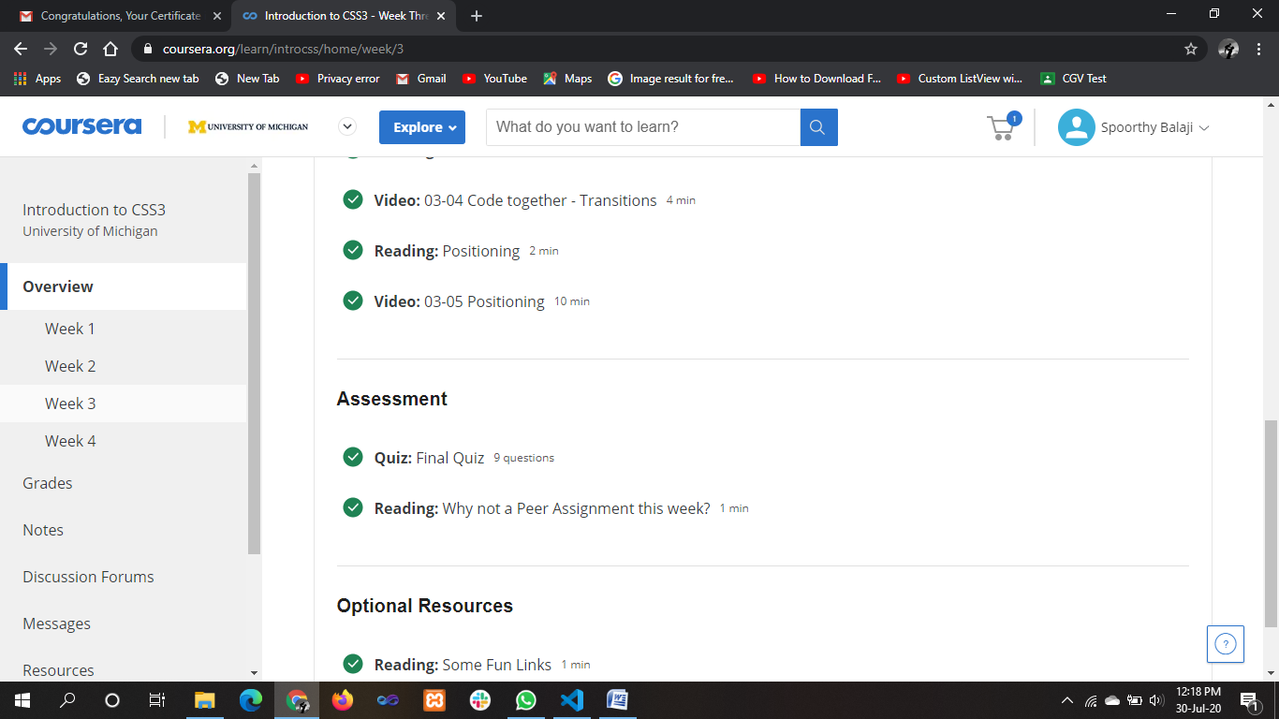

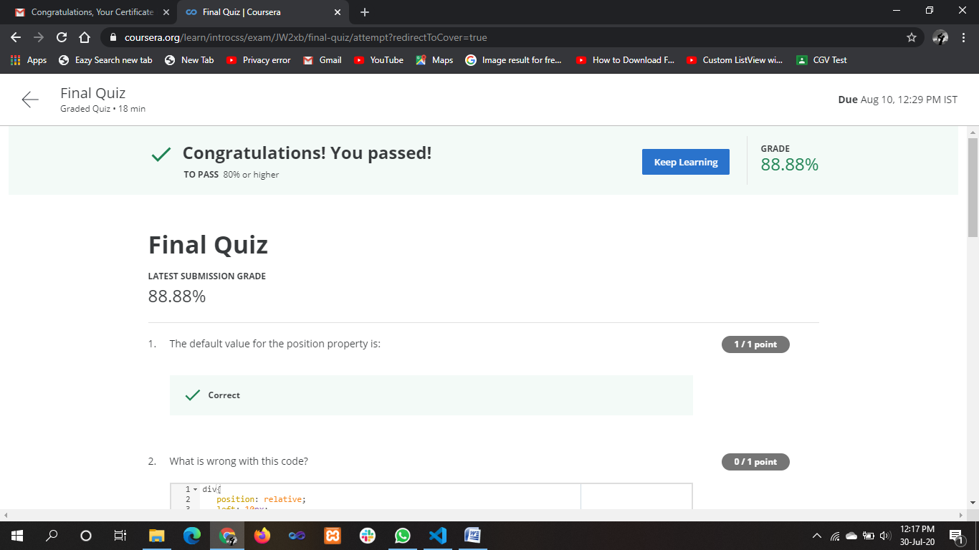

**ONLINE** **CODING**

**Python Program for Program to calculate area of a Tetrahedron**

import math

def area_of_tetrahedron(side):

return (math.sqrt(3) * (side * side))

side = 4;

print("Area of Tetrahedron =", area_of_tetrahedron(side));

